# Brainstorm

## Before we collaborate

### We have to make sure wether the IBM management provide us good data , we have to make proper planning , analyzing the problem and learn additional skills like storytelling , stakeholder analysis , etc.

**1**

## Applicant Credibility Prediction for Loan Approval

### This data science project will help finance and banking people who give 100's of loan to their applicant and this group project will help stakeholder will come to the number if applicant who are eligible and not eligible by using data visualization , machine learning algorithms and stakeholder will make data driven decisions from this project.

**2**

## Brainstorm

### Ideas that come to mind that address your problem statement.

**3**

## Group ideas

### Share ideas and we can make further planning based on mentor feedback.

**4**

## Prioritize

### Your team should all be on the same page about what's important moving forward. Place your ideas on this grid to determine which ideas are important and which are feasible.

**20 minutes**

# & idea prioritization

#### Team gathering

Prathy(team leader) will gather group and instruct , ask

**PROBLEM**

#### Ananthi

**Kaviya**

#### Kalaiselvi

**Rojai**

**Mohammed Afridi**

Refactor code if possible , use clean visuals and use required libraires to reduce complexity

**Durai**

Use Matplotlib

**Prathy**

Use Numpy , pandas , plotly

idea and lead the group further.

**We are gonna solve this problem by using**

* 1. Get Big
  2. Clean values by outlier detection ,
  3. Remove abnormal

1.use apache to

2.use matplotlib to

1. Use Neural
   1. Use seaborn to
   2. Do statistical analysis 3. Use tensorflow for

training model more

* + 1. Try to keep
    2. Do proper Refactoring of
    3. Try to achieve more accuracy by

**Prathy**

Use Plotly for interactive graphs or visualization, use xgboost and scikit learn for preprocessing and training model. Use Kaggle to learn code from experienced persons as it is a data science community

**Vadivel Karthick**

Use seaborn for clean visualization , use testing techniques if possible.

In this Template share ideas and further ideas can be written here to modify accordingly , leader will modify these chart based on mentor feedback.

**2 months** to prepare

**1 month** to collaborate

**4 Members**

#### Set the goal

Higher Accuracy. Clean Visuals.

Clean Code. More Insights

#### Learn how to use the facilitation tools

* 1. Youtube and IBM sessions to learn concepts.
  2. Use documentation to code new concepts.
  3. use discord , stackoverflow to clear doubts.

## machine learning algorithms using sci-kit

**Learn and other conventional libraries like spark to handle big data, numpy and pandas for reshaping, cleaning data, etc.**

data

* 1. Use Xgboost Regression

7.Find out which model fits the problem ie.

Random forest,svm,logistic regression by scikit learn.

**Durai**

Use aws , azure to deploy model and training model use seaborn. Use kaggle and github for reference

removing null

value by mean/ median

5.Preprocess data to reduce computation strain

data from csv/txt file

6.Evaluate The model.

store big data

create clean visuals

Network For

this problem.

visualize

data

i.e.Inferential

statistics,descriptive statistics,etc

particular use keras

for creating layers for neural network

ideas clean

and neat

code and clean

visualization patterns.

repeated epochs

and do parameter tunning.

**Prathy**

Use Apache spark to store big data

**Durai**

Use Numpy , pandas , Matplotlib

## Importance

**Prathy**

Use aws or azure for model training and deploying model.

**Durai**

Use charts like barchart , piechart , ribbon chart based on data provided

**Prathy**

Use Xgboost for regression

If each of these tasks could get done without any difficulty or cost, which would have the most positive impact?

##### Vadivel

Use seaborn , numpy

,pandas which are

commonly used libraries in data science project.

**Afridi**

Clean code ,clean visuals , Higher accuracy.

**Prathy,Vadivel Karthick**

use Neural network if possible

[**Share template feedback**](https://muralco.typeform.com/to/CiqaHVat?typeform-source=app.mural.co)

## Feasibility

Regardless of their importance, which tasks are more feasible than others? (Cost, time, effort, complexity, etc.)

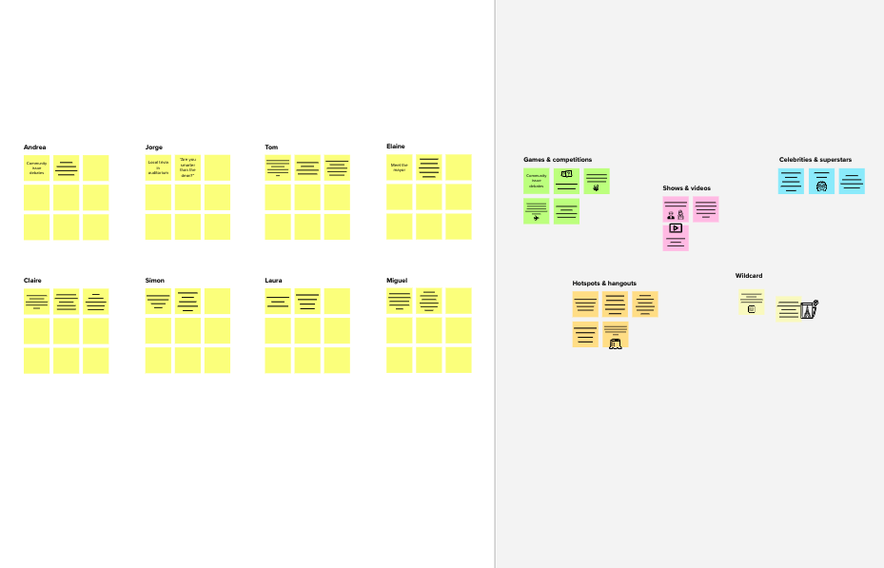

**Need some inspiration?**

See a finished version of this template to kickstart your work.

[**Open example**](https://app.mural.co/template/e5a93b7b-49f2-48c9-afd7-a635d860eba6/93f1b98d-b2d2-4695-8e85-7e9c0d2fd9b9)